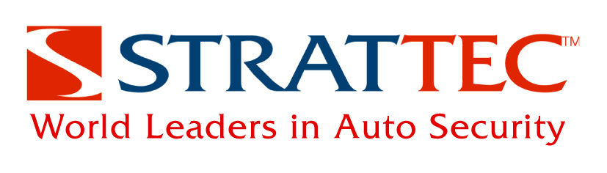

STRATTEC Security Corporation Company Background
The world leader in automotive security, STRATTEC® Security Corporation designs, develops, manufactures and markets mechanical locks and keys; electronically-enhanced locks and keys; steering column and instrument panel ignition lock housings; latches; and related access control products for North American automotive customers. STRATTEC additionally provides product to global automotive manufacturers through the VAST Alliance in which it participates with WITTE Automotive of Velbert, Germany and ADAC Automotive of Grand Rapids, Mich.
STRATTEC Power Access, a subsidiary organization, designs, develops, tests, manufactures, markets and sells power systems to operate vehicle sliding side doors and rear compartment access points such as liftgates and trunk lids. The product line also includes power cinching latches and cinching strikers used in these systems.
In addition, STRATTEC offers the BOLT (Breakthrough One-Key Lock) series of locks, which open with their owner’s vehicle key, eliminating the need to carry extra keys or remember a combination. BOLT locks are the first consumer products marketed by the company.
STRATTEC's history in the automotive business spans 100 years. STRATTEC Security Corp. common stock is traded on the NASDAQ under symbol STRT. For more information, visit www.boltlock.com.
# # #

